Made to measure
If you are having the grills made to measure it is vital that you give me accurate measurements. Please give me "spot on" dimensions, DO NOT make any allowance for fitting. Of course the grills have to be slightly smaller so that they can be fitted or taken off quickly but it is better for me to make that allowance. I have to consider where the cuts and/or folds fall in relation to the perforations and will make a 1-2mm reduction in the dimensions to facilitate this. Obviously if you have already allowed 2mm for fitting then the grills are going to come out 3-4mm smaller. So PLEASE, accurate measurements, no allowance.
In the picture below, the edge of the cab is between 426 and 427mm. Read it as 426 but DON'T make any allowance for fitting. See above. The maximum sheet size I keep in stock is 1800mm x 680mm. I can get larger sheets if required but they would be a special order.

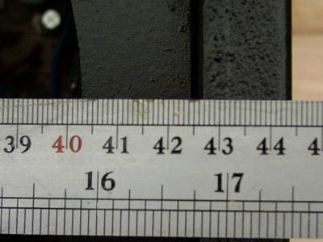

Do it Yourself

It's quite easy to cut to size. I use an angle grinder with a very thin cutting disc (0.8mm or 1mm). I screwed a couple of battens across the shed door and hang the sheet vertically off a couple of nails (cut the heads off the nails). Then just put a 3/4" screw thru one of the perforations to hold it and cut with the angle grinder.

You will need a 115mm angle grinder and there are a couple of discs which you will find essential. On the left of the photo is a 0.8mm cutting disc and on the right is an abrasive flapwheel disc. It is essential to wear eye protection when using any power tool. You should be able to find both at your local DIY store for a couple of pounds each but if you have any difficulty I can supply them.
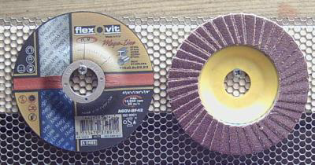

When cutting the sheet to size aim to cut it slightly larger, then reduce with the flapwheel disc. There are two different techniques to cutting the sheet. If you look at the sheet the perforations run in straight lines up and down the length, whereas they are staggered across the width. For a lengthwise cut (to reduce the width) mark the row of holes with a felt marker pen and cut straight down the line.

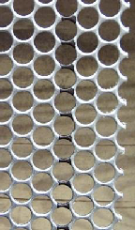

For a width cut (to reduce the length) you need to mark every other hole as shown in the photo. Use the line as a guide but leave the line and cut to one side of it. Since the cutting blade is 1mm or less thick it will naturally take the path of least resistance, and will leave the cut edge as a series of full hole, half hole etc. Look at the top or bottom edge of the photo to see what I mean.

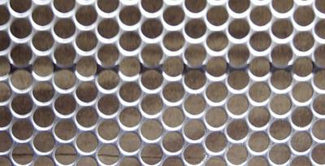

The sheet is quite easy to fold. Simply clamp two pieces of wood either side of the sheet (use G clamps or similar) and hammer the fold.

